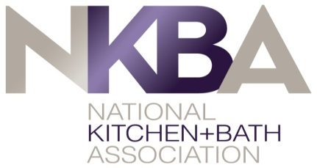 (use chapter logo)

CHAPTER APPROVAL OF APPLICATION FOR STUDENT CHAPTER FORMATION

This application for student chapter formation with the National Kitchen and Bath Association is made with the approval of ___________________ (name of NKBA chapter). The new student chapter is an organized group of students attending ____________________ (name of school).

The chapter agrees to:

- Appoint a chapter officer as liaison to the student chapter
- Share chapter calendar with student officers and invite students to all chapter meetings
- Provide at least one student-focused chapter meeting/event and invite student members
- Encourage student mentoring
- Consider students as committee members for professional chapter

The applicant student chapter agrees to:

- Be comprised of students enrolled in courses with the above-mentioned school
- Receive the approval of the appropriate officials with the educational institution
- Appoint student officer to be the liaison to the professional chapter
- Share student calendar with chapter
- Encourage students to attend chapter meetings

___________________ ___________ _________________ ___________
NKBA Chapter Officer Date School Official Date

____________________ ___________
Student Officer Date

