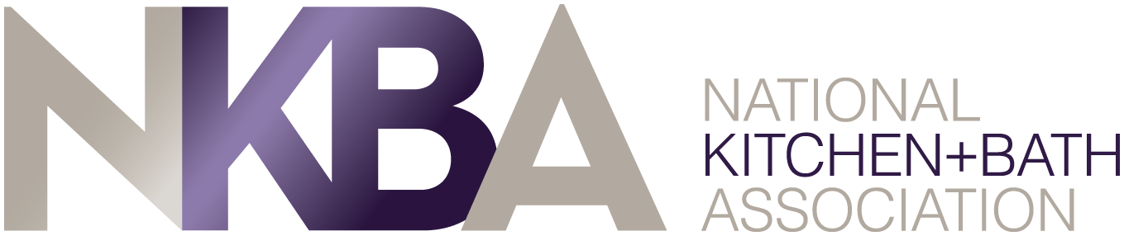

Not an NKBA member – LOOK WHAT YOUR’E MISSING!

As a member of NKBA, the owner of KBIS, you are part of the only trade association dedicated exclusively to kitchen and bath design, construction and remodeling, and the leading source of information for consumers and professionals alike in that space.

Become a member and MAXIMIZE your Association benefits. Members have the exclusive benefit of hosting or sponsoring an NKBA chapter meeting which will bring recognition to your company. Imagine the benefits of having 20+ industry professionals come to your place of business.

Be a host
- The chapter can invite members to your showroom or place of business providing local professionals with a knowledge of who you are
- Invite your own contacts too!
- Industry professionals will learn more about your business and opens the possibilities for new relationships
- Hosts can also offer a presentation on a generic topic which gives the company a double benefit – location awareness and company expertise

Be a sponsor
- Event sponsor - No showroom? No worries! Be a sponsor and still be given the opportunity to promote your business
  - Sponsors will be noted on any chapter event advertising
  - Sponsors will be given the opportunity to briefly promote their company at the beginning or end of the event.
- Chapter sponsorships - Chapters use the name and address of sponsor companies on their website or newsletters

And don’t miss additional NKBA member benefits
- A NEW enhanced mobile-first website to make connecting with other industry professionals and consumers better, faster and more efficient. The mobile first platform can be used with iPads, Androids, iPhones, laptops and more.
- FREE Member Profiles for all NKBA Members, including:
  - Profile photo or company logo
  - Member bio
  - Company description
  - Products offered by category
  - Brands available
  - Location mapping tool
  - Photo gallery of projects, showrooms and more
- Learning and the power of networking opportunities. Take courses (even Free monthly courses) and attend meetings or other industry events
- Company exposure through hosting, sponsoring and speaking opportunities
- Access to high level information and research

Don’t wait – stand out in your profession. Take part in NKBA today!
CALL YOUR LOCAL CHAPTER

