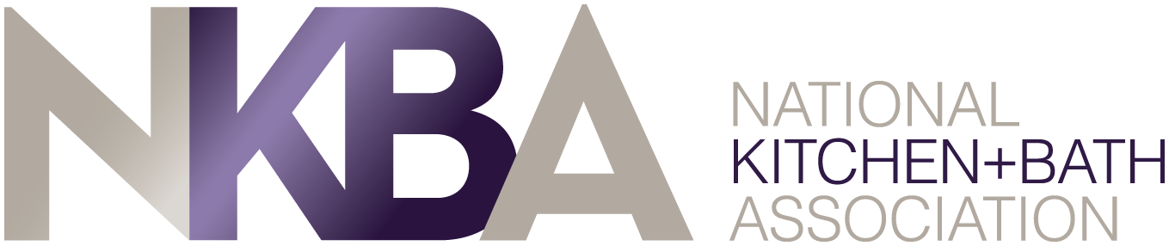

NKBA COMPANY MEMBERS
YOU’RE INVITED TO HOST OR SPONSOR A CHAPTER EVENT

As a member of NKBA, the owner of KBIS, you are part of the only trade association dedicated exclusively to kitchen and bath design, construction and remodeling, and the leading source of information for consumers and professionals alike in that space.

Are you MAXIMIZING your Association Benefits? Don’t miss out! Get in front of your members and host or sponsor an NKBA chapter meeting. It’s a member-only benefit and can bring recognition to your company. Imagine the benefits of having 20+ industry professionals come to your place of business.

Be a host:
- The chapter can invite members to your showroom or place of business providing local professionals with a knowledge of who you are
- Invite your own contacts too!
- Industry professionals will learn more about your business and opens the possibilities for new relationships
- Hosts can also offer a presentation on a generic topic which gives the company a double benefit – location awareness and company expertise

Be a sponsor
- Event sponsor - No showroom? No worries! Be a sponsor and still be given the opportunity to promote your business
  - Sponsors will be noted on any chapter event advertising
  - Sponsors will be given the opportunity to briefly promote their company at the beginning or end of the event.
- Chapter sponsorships - Chapters use the name and address of sponsor companies on their website or newsletters

Don’t wait – stand out in your profession. Take part in your association today!
CALL YOUR LOCAL CHAPTER

