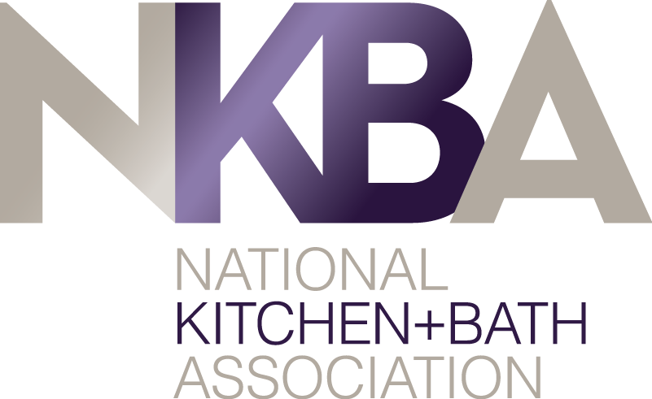

Recruitment Committee

Role

The Recruitment Committee is made up of qualified knowledgeable NKBA members who represent the best interests of the Chapter membership.

The committee is responsible for:
- Generating member interest in becoming a volunteer
- Reviewing chapter officer’s terms by position to be aware of upcoming open positions

Chapter Council Officer positions:
- President
- Secretary/Treasurer
- Communications Chair
- Membership Chair
- Programs Chair

Terms: All officer terms are one 2-year term with the option to self-nominate for a second 2-year term

Once an officer has served for four years, they must be off the council for at least two years.

All councils will have three permanent committees: Communications, Membership and Programs

Responsibilities

- Interview, review and identify individuals qualified to become chapter officers
- Evaluating the relative strengths and weaknesses of the pool of potential officers
- Review the credentials of those individuals nominated to serve the chapter and make recommendations. It is not the Committee’s role to select new officers, however, the committee can make recommendations.
- Prepare a slate of officers for approval by the Chapter Council and identify the recommended candidates. The Secretary/Treasurer will verify each candidate’s eligibility and email the Recruitment Committee’s final selection of officers to National for their review.
- Throughout the year, the Recruitment Committee interviews potential candidates for chapter officer positions so they have available a pool of candidates to replace an officer that resigns and to prepare for officer elections the next year.

