FOR IMMEDIATE RELEASE

Contact: Kelly Winkler Jocelyn Hutt
White Good White Good
717-690-9768 717-725-0291
kwinkler@whitegood.com jhutt@whitegood.com

The National Kitchen & Bath Association (NKBA) Announces
NKBA Education is Genius Program
“NKBA Education is Genius” Provides Broad Spectrum of
All-industry Education Initiatives

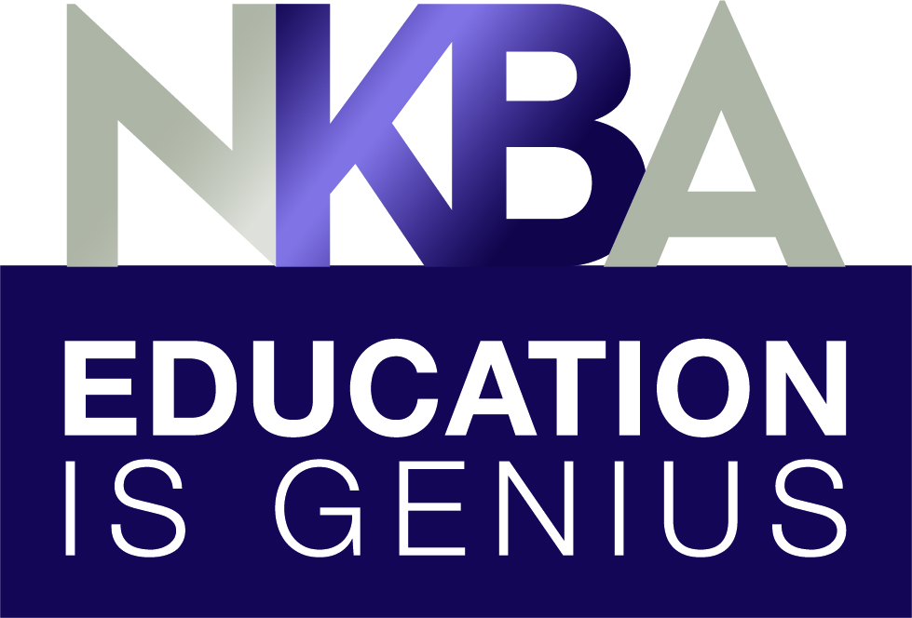
HACKETTSTOWN, NJ — (December 6, 2018) — The National Kitchen & Bath Association (NKBA), the authority on all things residential kitchen and bath, announces the launch of “NKBA Education is Genius” — the Association’s all-industry Professional Development and Educational Program umbrella. Under this over-arching theme, a series of educational programs, designed to serve the entire industry on a variety of platforms, gives all NKBA members many opportunities to continue to demonstrate authority in the kitchen and bath industry.

The association developed the “NKBA Education is Genius” program to appeal to all of its members, including, but not only limited to, kitchen and bath designers. Members of the NKBA are engaged in all areas of the design industry; from installers and supply houses to manufacturers, dealers and showroom managers, and as such, the new education programming ensures that a variety of educational tools are available to every member.

“NKBA Education is Genius” has five key components:

Living in Place Certification: Certified Living in Place Professional (CLIPP)
The Living in Place Institute (LIPI) Certification Program, endorsed and offered by the NKBA, addresses the needs of industry professionals who participate in making all homes more accessible, comfortable and safe for everyone, regardless of their current needs or age. NKBA members receive deep discounts on CLIPP training programs.

NKBA Affiliated Colleges and Student Programs
More than 130 NKBA affiliated colleges offer kitchen and bath design programs to over 3,000 NKBA student members preparing them for rewarding careers in the kitchen and bath industry.

-more-

NKBA Certification, Planning Guidelines and Online Knowledge Base
Recognized as the hallmark for kitchen and bath professionals, NKBA certification serves as an endorsement of professional experience and design expertise. Based on in-depth testing, industry experience and continuing professional development and offering new opportunities for earning continuing education units (CEUs).

NKBA Kitchen & Bathroom Planning Guidelines are being reviewed and revised to address the way people live today. Subject matter experts are collaboarting with the NKBA Professional Development team to update the guidelines to reflect today’s kitchens and baths.
A new online resource, based on the NKBA Professional Resource Library, is a collaborative project where the community can contribute new expert knowledge to revise existing material. All submissions are vetted by subject matter experts to ensure accuracy.

Virtual, Web-based Training Programs
Free, 60-minute webinars are presented by leading industry subject matter experts. Topics for 2019 include: Residential Kitchen & Bath Design: Sustainability, Smart Home Technology, New Design Trends, Sales and Marketing, Outdoor Living Spaces, Lighting, Design Software and more.

Specialty Badge/Micro-credentialing Program
The Speciality Badge program enables all NKBA members the opportunity to demonstrate focused knowledge in a number of specialty areas: Sales & Marketing, Cabinetry, Remodeling, Living in Place and Floor Plans & Specifications badges will debut at KBIS 2019.

The NKBA has long held education as one its founding principles and as such, the Professional Development team worked for two years to develop new and refine existing programs. Collaborating with subject matter experts, fielding research and integrating technology and new platforms into the mix, has produced an industry leading approach to professional development and education.

“We believe that the core of our mission as an association is to help spread best practices and authoritative information to the professional and aspiring practitioner in the kitchen and bath industry,” says Jason Solomon, senior manager of member services & professional development. “The team worked to setup systems to make sure that our information is current, authoritative, and available for our members when, where, and how they need to access it. I could not be more proud of our new and refined offerings and we are excited to be a resource for our members and the industry as a whole.”
Heading into 2019, the NKBA “Education is Genius” program will come to life in front of the largest audience of NKBA members; the Kitchen and Bath Industry Show (KBIS), taking place in Las Vegas, February 19 – 21, 2019. At the show the NKBA will host Genius Hours daily in the NKBA booth located in the North Hall #N2627. These one hour sessions will introduce attendees to the various

-more-

NKBA education activations happening in and around the show. Each one hour session will be
eligible for 0.1 NKBA CEUs. Subjects will include: Planning Guidelines Review, Voices From The Industry overview, Certification updates and Exam Prep Bundle Packages overview, Specialty Badge and Micro-credentialing overview and the Certified Living In Place Professional™ (CLIPP) programs.

“NKBA’s abundant learning opportunities remain a cornerstone of the association’s offerings, and as such, our Professional Development Department never rests on its laurels. I’m extremely proud of these new initiatives; we understand that we have to meet our members where they are, and each of these programs was designed to help elevate members in key areas that we know will be most beneficial to their professional needs and requirements,” said Suzie Williford, chief strategy officer and executive vice president of Industry Relations, NKBA.

For more information, go to https://nkba.org/info/certification. For more information about the CLIPP program, visit https://nkba.org/CLIPP.

About the National Kitchen & Bath Association and the Kitchen & Bath Industry Show
The National Kitchen & Bath Association (NKBA) is the not-for-profit trade association that owns the Kitchen & Bath Industry Show® (KBIS), as part of Design & Construction Week® (DCW). With nearly 14,000 member companies representing tens of thousands of members in all segments of the kitchen and bath industry, the NKBA has educated and led the industry since the association’s founding in 1963. The NKBA envisions a world where everyone enjoys safe, beautiful and functional kitchen and bath spaces. The mission of the NKBA is to inspire, lead and empower the kitchen and bath industry through the creations of certifications, marketplaces and networks. For more information, visit NKBA.org or call 1-800-THE-NKBA (843-6522).

KBIS® and NKBA® are registered trademarks of the National Kitchen & Bath Association.

###

