FOR IMMEDIATE RELEASE

Contact: Kelly Winkler Jocelyn Hutt
White Good White Good
717-690-9768 717-725-0291
kwinkler@whitegood.com jhutt@whitegood.com

NKBA: Size of the Kitchen and Bath Market is $158.11 Billion
National Kitchen & Bath Association research estimates K&B market at $158 billion in 2017, up nearly 7.5% over 2016

HACKETTSTOWN, NJ — (February 20, 2019) — The National Kitchen & Bath Association released the results of its extensive Kitchen and Bath Market Outlook, revealing a value of $158.11 billion in sales of products and materials aimed at the residential kitchen and bath market in 2017, a 7.3% improvement over 2016.

This contributes to the $644 billion overall residential construction market, which includes $330 billion from the construction of new homes and $314 billion from residential remodeling and replacement (R&R) projects. Construction of new houses rose 8.6% in 2017, to reach a market size of $330 billion. Remodeling and improvement of existing homes (i.e., residential remodeling) amounted to $314 billion in 2017. This is 6.4% higher than it was in 2016.

To note:

- The U.S. residential kitchen and bath market spiked 7.3% to $158.11 billion in 2017 (for materials only, excluding design and labor costs), surpassing the 2016 spending level of $148 billion.
- At $158 billion, the U.S. residential kitchen and bath market represents one quarter of the entire U.S. residential construction market.
- Overall spending for kitchen and bathroom products is virtually even, with each category garnering 50% of the market (i.e., $80 billion for kitchen products and $78 billion for bath products).
- Of this $158 billion total, $99 billion (63%) is generated by remodeling and replacement projects in existing homes and the remaining $59 billion (37%) comes from new home construction.

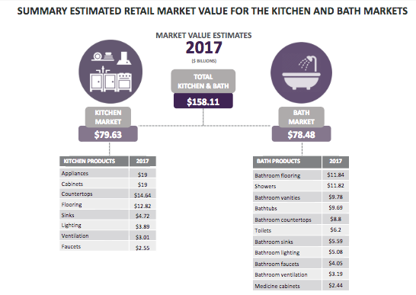

The NKBA 2018-2019 Kitchen and Bath Industry report produces the 2017 market size information for the following:

- By residential market segment: new housing construction; remodel and replacement.
- By product category: 9 kitchen and 12 bathroom product categories.
- A total of 775 surveys were conducted among builders, remodelers and general contractors, soliciting information on their business activities and growth.
- A total of 550 consumer surveys were conducted with individuals who had completed a kitchen or bathroom remodel project in the past 12 months.
- The new housing projections were calibrated with actual housing construction data and changes in the value of new housing construction. The projections for the remodeling segment were calibrated based on the Joint Center for Housing Studies of Harvard University’s remodeling spending estimates

-more-

Furthermore, the NKBA estimates the U.S. residential construction market will continue to expand in both 2018 and 2019. For 2018, NKBA estimates residential construction will rise to $683 billion, up 6% from 2017. A further 4.8% growth is projected for 2019, bringing the residential construction market to $716 billion.
.
“Our research reveals the strong position of the kitchen and bath industry, which is particularly significant in times of a fluctuating economy," said Bill Darcy, NKBA CEO. "This research is an invaluable tool that helps our membership with strategic business decisions, and solidifies NKBA's thought leadership in the industry."

The Executive Summary and Full Report of the NKBA 2018-2019 Kitchen & Bath Industry Outlook is available to editorial press free of charge. Editorial press may request the report by contacting Kelly Winkler or Jocelyn Hutt (contact information listed herein).

About the National Kitchen & Bath Association and the Kitchen & Bath Industry Show
The National Kitchen & Bath Association (NKBA) is the not-for-profit trade association that owns the Kitchen & Bath Industry Show® (KBIS), as part of Design & Construction Week® (DCW). With nearly 14,000 member companies representing tens of thousands of members in all segments of the kitchen and bath industry, the NKBA has educated and led the industry since the association’s founding in 1963. The NKBA envisions a world where everyone enjoys safe, beautiful and functional kitchen and bath spaces. The mission of the NKBA is to inspire, lead and empower the kitchen and bath industry through the creations of certifications, marketplaces and networks. For more information, visit NKBA.org or call 1-800-THE-NKBA (843-6522).

KBIS® and NKBA® are registered trademarks of the National Kitchen & Bath Association.

###

