**FOR IMMEDIATE RELEASE**

Contact: Kelly Winkler Alexandra (Alex) Lashner

White Good White Good

717-690-9768 717-693-3442

kwinkler@whitegood.com [alashner@whitegood.com](mailto:alashner@whitegood.com)

**The National Kitchen & Bath Association Launches KBTalks Podcast**

Episodes to feature candid conversations and advice on industry-critical topics, business strategies, trends and more *to help listeners navigate the kitchen and bath industry*

**HACKETTSTOWN, NJ — (April 29, 2019) —** The National Kitchen & Bath Association (NKBA), the authority on all things residential kitchen and bath, is launching its inaugural podcast, *KBTalks — Powered by NKBA,* with listening parties on May 1. The podcast is hosted by Elle H-Millard, CKD, CLIPP, 2019 NKBA Insider and NKBA industry relations manager, and Jennifer Bertrand, AKBD, 2017 NKBA Insider and home-design TV personality. It is the only podcast dedicated to growing and supporting the kitchen and bath industry.

“A podcast provides an innovative and unique way of communicating with our members and the industry at large on important topics that impact their businesses,” explained Suzie Williford, executive vice president, industry relations, and chief strategy officer for NKBA. “It’s an opportunity for the people within our industry to share their stories and real-world advice and to have smart and spirited discussions about the issues affecting us all.”

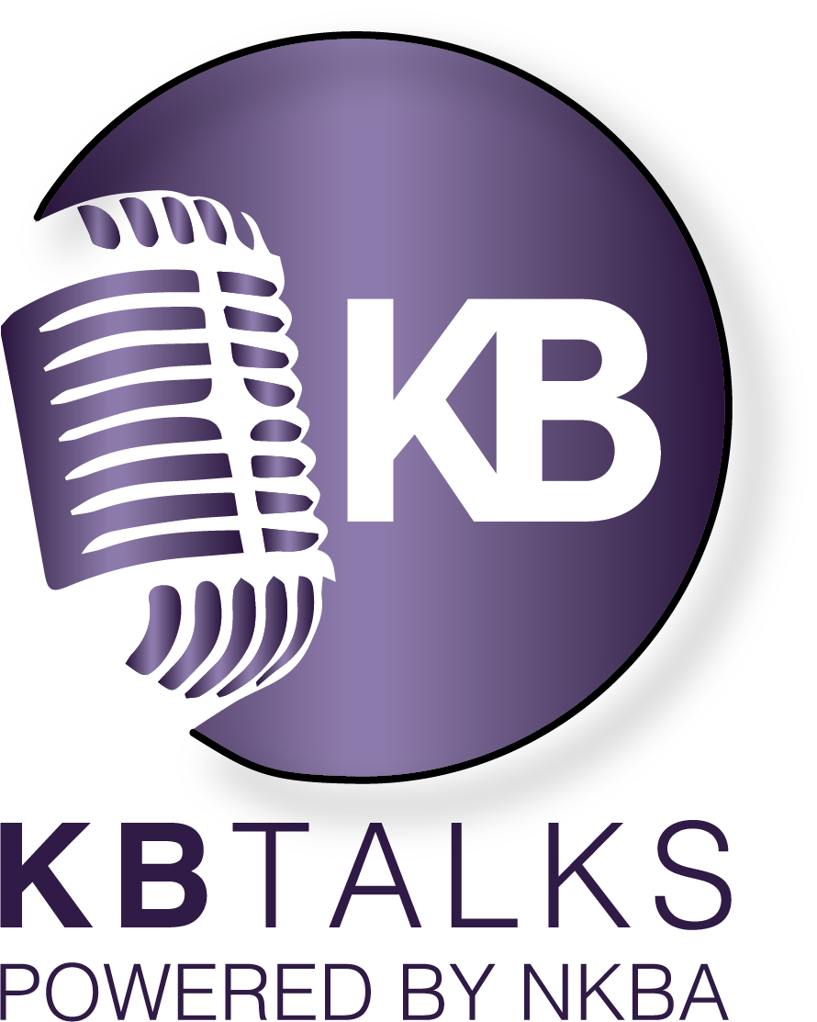On each episode, a specific industry-critical topic will be explored during in-depth conversations with special guests. Topics range from business strategies and marketing to trends, tech innovations and more. Guests include designers, brand experts, media and industry influencers, all discussing their perspectives and experiences working in the kitchen and bath industry.

The first eight episodes are now live and dive into topics such as the connected home, new product finds from KBIS 2019, tackling the skilled labor shortage and how color is relative — a debate on the 2019 “colors of the year.”

Below is a summary of a few of the episodes:

**The Connected Home**

Technology is impacting daily life and the K&B industry is no exception. Integrated tech is changing the way we communicate, the way we do business and the way we live. This episode

*-more-*

features expert tech guests Alex Capecelatro, CEO and co-founder of Josh.ai; Toni Sabatino, designer and president of the NKBA Manhattan Chapter, and Katye McGreggor-Bennett, CEO and chief strategist at KMB Communications.

**#NKBAInsiders’ Finds at KBIS 2019**

The 2019 NKBA Insiders scoured the KBIS 2019 show floor and presented their top finds in their respective areas of expertise on the KBISNeXT Stage. In this episode, tune into the panel from the show and hear about the products that made this group of experts say “WOW!”

**Beyond the Trends — Color is Relative**

Color creates emotion, positive or negative, and at no time is this more apparent than when Pantone, Benjamin Moore, Sherwin Williams and many others announce their COTY (Color of the Year). In response, designers take to the streets — or at least to Facebook, Pinterest and their blogs — to voice their opinions, share their inspiration and embrace or dismiss the current year's choice.

**Moderator:** Maria Killam, True Color Expert, Color Me Happy

**Panelists:** Rachel Moriarty, Rachel Moriarty Interiors; Vanessa Deleon, Vanessa DeLeon Associates; Brynn Olson, Brynn Olson Design Group, LLC

These episodes, plus five others from the KBTalks series, are available now on [Apple Podcasts](https://podcasts.apple.com/us/podcast/kbtalks/id1444655214), [Soundcloud,](https://soundcloud.com/user-171892082) and wherever podcasts are available. To kick off the launch, the NKBA is hosting a series of virtual listening parties on May 1, 2019. To register to attend, [click here](https://us6.campaign-archive.com/?u=a1288d6cb8adda7749f318d94&id=413fb6e555).

**About the National Kitchen & Bath Association and the Kitchen & Bath Industry Show**

The National Kitchen & Bath Association (NKBA) is the not-for-profit trade association that owns the Kitchen & Bath Industry Show® (KBIS), as part of Design & Construction Week® (DCW). With nearly 14,000 member companies representing tens of thousands of members in all segments of the kitchen and bath industry, the NKBA has educated and led the industry since the association’s founding in 1963. The NKBA envisions a world where everyone enjoys safe, beautiful and functional kitchen and bath spaces. The mission of the NKBA is to inspire, lead and empower the kitchen and bath industry through the creations of certifications, marketplaces and networks. For more information, visit NKBA.org or call 1-800-THE-NKBA (843-6522).

KBIS® and NKBA® are registered trademarks of the National Kitchen & Bath Association.

###