FOR IMMEDIATE RELEASE

Contact: Jocelyn Hutt Kelly Winkler
White Good White Good
717-725-0291 717-690-9768
jhutt@whitegood.com kwinkler@whitegood.com

The National Kitchen & Bath Association
Voices From The Industry (VFTI) Conference Returns to KBIS 2019

HACKETTSTOWN, NJ — (January 8, 2019) — The National Kitchen & Bath Association (NKBA), the authority on all things residential kitchen and bath, once again presents its tremendous learning opportunities at the upcoming Kitchen and Bath Industry Show (KBIS), happening February 19-21, 2019 at the Las Vegas Convention Center. The Voices From The Industry (VFTI) Conference features more than 80 speakers representing segments within the kitchen and bath industry as well as broader sessions offering insights and expertise in the areas of sales, marketing, technology and design.

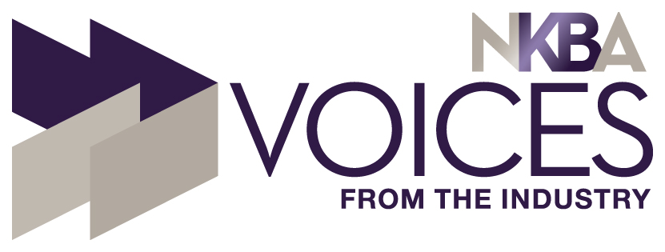
A defining pillar of the NKBA, the VFTI series offers members opportunities to learn from experts. New for 2019, the NKBA is presenting four two-hour courses as part of its VFTI Conference. The two-hour seminars offer 0.2 CEU Credits and two Education Hours toward earning or maintaining AKBD (Associate Kitchen & Bath Designer), CKBD (Certified Kitchen & Bath Designer) and CMKBD (Certified Master Kitchen & Bath Designer) certifications. The one-hour VFTI sessions offer 0.1 CEU and many qualify for other industry CEUs.

Also new this year at KBIS 2019, NKBA will conduct a special VFTI session offered specifically to students enrolled in training programs for careers in the kitchen and bath industry.

“Our Professional Development team continues to deliver on the NKBA promise to offer the most relevant courses possible,” said Suzie Williford, Chief Strategy Officer and Executive Vice President of Industry Relations for NKBA. “We understand that people attending KBIS have full agendas, so our goal is to offer VFTI sessions that prove to be beneficial and pertinent to kitchen and bath designers interested in professional development, as well as the design industry as a whole.”

For anyone interested in earning or maintaining AKBD, CKBD or CMKBD certification, the VFTI Conference is the place to start. The sessions are divided into the following tracks: Grow Your Business, Kitchen & Bath Specialty Training, Design, Management and Customer Service. Here is a taste of some of the available sessions:

Grow Your Business
Your Business and Your Life—Playing a Bigger Game
As a small business owner, do you feel that the next level of success seems out of reach? Do you struggle to get out of your own way, often feeling overwhelmed and frustrated? In this seminar, we will each examine how we see ourselves, our business, and the way we operate on a daily basis.-
-more-

Kitchen & Bath Specialty Training
The Connected Home: Adding Automated Technology to Your Projects
An introduction to connected/smart home technologies that can be incorporated into your next kitchen or bath project. This course will include information on dimming LED, dynamic lighting (Tunable White Light, Warm Dimming, RGB), DIY products and fully automated systems.

Design
Color and the Senses: Exploring Synesthesia + Current Color Trends
How does color affect taste and smell? Seeing a color may evoke any number of other sensations. For instance, green may be evocative of the smell of grass or lemon yellow may suggest a sour taste. In this session, attendees will gain an understanding and appreciation of how color influences the five senses through a phenomenon called “Synesthesia.”

Management
The Most Important Numbers You Must Know!
The effective use and interpretation of your KPIs can help you do a number of very critical financial management tasks including defining and measuring the progress you’re making toward your goals and helping you make informed decisions as to budgeting and resource allocation.

Customer Service
The Six Levels of Customer Service
Do you want to provide Unbelievable service or just Basic service or even worse, Underwhelming service? Where are you at today? We will work through some real-world examples to bring the concept of evaluating each project and sale based on six defined levels of customer service.

For Students
Growing Into a Career in the Kitchen & Bath Industry
This session is offered to students enrolled in training programs and/or those looking to move into a new role within the K&B industry. The session outlines opportunities within the industry from Design, Sales, Sales Management, Project Management and Territory Management.

To see the full listing of VFTI courses offered at KBIS 2019, click here. To register to attend KBIS 2019, click here.

About the National Kitchen & Bath Association and the Kitchen & Bath Industry Show
The National Kitchen & Bath Association (NKBA) is the not-for-profit trade association that owns the Kitchen & Bath Industry Show® (KBIS), as part of Design & Construction Week® (DCW). With nearly 14,000 member companies representing tens of thousands of members in all segments of the kitchen and bath industry, the NKBA has educated and led the industry since the association’s founding in 1963. The NKBA envisions a world where everyone enjoys safe, beautiful and functional kitchen and bath spaces. The mission of the NKBA is to inspire, lead and empower the kitchen and bath industry through the creations of certifications, marketplaces and networks. For more information, visit NKBA.org or call 1-800-THE-NKBA (843-6522).

KBIS® and NKBA® are registered trademarks of the National Kitchen & Bath Association.

